Stage 1 (1/2C) 16/8/21 – 20/8/21
This pack includes a variety of both digital and non-digital activities. You will need help from a parent/carer and the resource pack from your teacher.
 | Day 1 | Day 2 | Day 3 | Day 4 | Day 5
Morning | **No Zoom today**  English  Read a book to yourself or someone at home  Watch:‘10 Steps to Washing Your Hands’  L.I: To plan a procedural text that instructs others about how to wash their hands correctly  S.C: My plan includes:  - An aim  - Materials needed  - Time connective examples  - action verbs & vocabulary required  Independent writing. Draw/write your own procedure plan about how to wash your hands  Upload your writing plan to Seesaw. We will discuss these in tomorrow’s Zoom lesson | English  Record yourself reading a book to yourself or someone at home. Upload your recording to Seesaw.  Watch:‘10 Steps to Washing Your Hands’  L.I: To compose a procedural text that instructs others about how to wash their hands correctly  S.C: My procedure includes:  - An aim  - Materials needed  - Clear steps using time connectives  - Action verbs, e.g. turn, rub...  Morning Circle & Modelled Writing (9:30am): Whole class modelled procedure composing (How to wash your hands)  Independent writing. Use your plan from yesterday to compose your own procedure about how to wash your hands.  Upload your composing to Seesaw | English  Read a book to yourself or someone at home. Draw a picture of your favourite part and upload it to Seesaw.  Watch: ‘How to Wash a Woolly Mammoth’ by Michelle Robinson & Kate Hindley  L.I: To revise a procedural text  S.C:  - I have included action verbs, e.g. turn, wash, rub...  - I have read my procedure to someone  - My writing is in sequenced steps, e.g. first, second...finally  - I have added further detail to my writing, e.g. adverbs (quickly, firmly etc)  Morning Circle & Modelled Writing (9:30am): Whole class modelled revising (How to wash your hands)  Independent writing. Revise your procedure about how to wash your hands. Upload your revised procedure to Seesaw | English  Record yourself reading a book to yourself or someone at home. Upload your recording to Seesaw.  Watch: ‘Wombat Stew’ by Marcia K Vaughan and Pamela Lofts  L.I: To edit my procedure writing  S.C:  - I have used capital letters and full stops  - I have checked my spelling  - I have done a final read/check of my writing  - I have asked someone else to read over my work  Morning Circle & Modelled Writing (9:30am): Whole class modelled procedure editing (How to wash your hands)  Independent writing. Edit your own procedure about how to wash your hands  Upload your revised procedure to Seesaw | English  Read a book to yourself or someone at home. Think of an alternative ending to the story.  L.I: To publish my procedure writing  S.C:  - I have written my writing out neatly.  - I have used even spacing between words and stayed within the lines  - I have illustrated my procedure  Morning Circle & Publishing a procedure discussion (How to wash your hands)  Independent writing. Publish your own procedure about how to wash your hands.  Upload a picture of your published (inc. illustration) procedure to Seesaw
Break | Break | Break | Break | Break | Break
Middle | Mathematics  Number Talk  L.I: Use a range of strategies for multiplication and division  S.C: I can use objects to model equal groups as a multiplication strategy  Independent activity:  Click on and play the ‘groups of’ activity  - Read the question or click on the speaker  - Type your answer or click on the answer | Mathematics  Number Talk  L.I: Sort, describe, represent and recognise familiar 3D objects, including cones, cubes, cylinders, spheres and prisms  S.C: I can recognise that 3D objects look different from different points of view  Explicit Teaching (12:30pm): 3D objects from different points of view  Independent activity:  - Find three (3) 3D objects in your house. These could include… a can of fruit, a cereal box, a ball, a cup, a container or an apple.  - Take photos of that object from different points of view (different angles)  - Logon to Seesaw  - Complete and upload the assigned 3D shape task | Library (12:30 pm)  Enjoy a library session with Mrs Mitchell.  Mathematics  L.I: Use a range of strategies for multiplication and division  S.C: I can use objects to make an array of equal rows and columns  Independent activity:  Watch the Array video  Then, Logon to Seesaw.  Complete and upload the assigned array task | Mathematics  L.I: Sort, describe, represent and recognise familiar 3D objects, including cones, cubes, cylinders, spheres and prisms  S.C:I can  - Tell the difference between flat and curved surfaces  - Use the term ‘faces’ to describe flat surfaces with straight edges  Independent activity:  - Logon to Seesaw  - Complete and upload the assigned 3D shape sorting task  - Find an older sibling or parent to play “What am I - 3D shape edition’.  - Choose a 3D shape and then describe its properties (faces and corners)  - See if they can guess correctly. | Mathematics  Number Talk  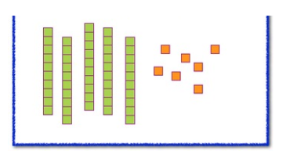  L.I: Apply place value, informally, to count, order, read and represent two- and three-digit numbers  S.C: I can partition (expand) a range of numbers of up to three digits.  Explicit Teaching (12:30pm): Partitioning - representing numbers in expanded form (as well as in addition sums )  Independent activity:  - Logon to Seesaw  - Complete and upload the assigned partitioning task
Break | Break | Break | Break | Break | Break
Afternoon | Geography  Review content that was covered in our previous geography lessons  Look through the booklets under Geography lesson 4 to refresh your memory.  Complete the worksheets and submit your work on Seesaw. | PDH  Logon to Seesaw. Select the ‘Mindfulness Activity for Kids’ activity. Follow the instructions.  Logon to Seesaw Complete the ‘My Lost Mob’ activity and upload your response. | Science  Focus question: How and why do we collect information about the weather?  Login to seesaw and complete the weather collectors activity. | Creative Arts  Logon to Seesaw. Select the ‘Musical Moods’. Follow the instructions.  If you would like some extra fun Complete the ‘My Musical Scavenger Hunt’ activity and upload your response. | PE  Logon to Seesaw  Select the ‘PE Obstacles Lesson Week 6’.  Follow the instructions.
Wellbeing | 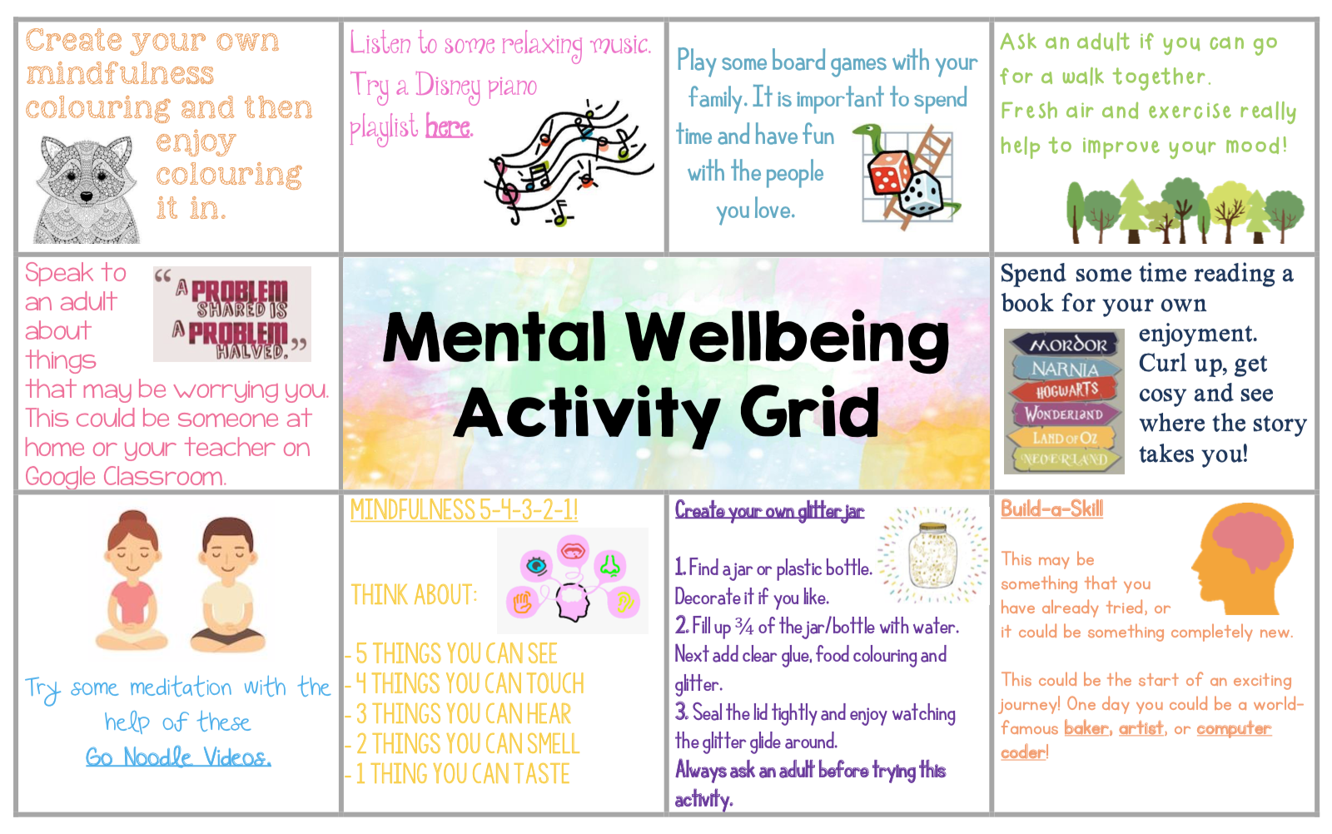  Complete one of the mental wellbeing activities! | Complete one of the mental wellbeing activities! | Complete one of the mental wellbeing activities! | Complete one of the mental wellbeing activities! | Complete one of the mental wellbeing activities!

