KSN 16/8/21 – 20/8/21
This pack includes a variety of both digital and non-digital activities. You will need help from a parent/carer and the resource pack from your teacher.
 | Day 1- Mrs Neil | Day 2- Mrs Neil | Day 3- Miss Schimann | Day 4- Miss Schimann | Day 5- Mrs Neil
Morning | 9:00am English  Morning Circle  Writing lesson  Purpose- plan ideas to use in our writing.  Audience- ourselves  Learning Intention- Plan ideas of what the butcher birds should be apologising for.  Success Criteria-  1.I can draw ideas of the horrible things the butcher birds did to mad magpie.  Text:  Mad Magpie: https://www.youtube.com/watch?v=-msPXr-cwLA  ]  Daily 5  1.Read a book to your family.  2. List word practice  3. Facts about Butcher Birds | 9:00am English  Morning Circle  Writing lesson  Purpose- write a letter from the butcher birds to apologise to mad magpie.  Audience- mad magpie  Learning Intention-  Re read our writing.  Success Criteria-  1.I can read my writing to know what comes next.  2.I can read my writing to check it makes sense for my audience.  Text:  Pig the Slob:  https://www.youtube.com/watch?v=emJlah7GWIM  Daily 5  1.Read a book to your family.  2. sh digraph activity  3. Design, draw and label a home for the butcher birds. | 9:00am English  Morning Circle  Writing lesson  Purpose- write a letter from the butcher birds to apologise to mad magpie.  Audience- mad magpie  Learning Intention-  Continuing with ideas  Success Criteria-  1.I can add to and extend on my ideas.  Sport:  Warm up:  Bounce a ball on your hand 20 times.  Activity:  Using a tennis racquet, cricket bat, ping pong paddle, practice throwing the ball in the air infront of you and hitting it **underarm** on its way back down. Try hitting some targets in your backyard. | English  Writing lesson  Purpose- revise our writing to make improvements.  Audience- Mad Magpie  Learning Intention-  Correct use of capital letters and full stops.  Success Criteria-  1.I can edit my writing to check I have correctly used capital letters and full stops.  Activity: Edit your letter for the correct use of capital letters and full stops and upload to seesaw.  Text:  John Brown and the Midnight Cat:  https://www.youtube.com/watch?v=_CM6tWhfT7Q  Daily 5  1.Read a book to your family.  2. Phonemic Awareness activity  3. Write a letter to one of your friends at school. | 9:00am English  Morning Circle  Writing lesson  Assessment Task  Mad Magpie  Vocabulary- Positive words that create a happy mood.  Posters decorated in the style of the book using dot painting, print making or drawing or a combination.  Text:  Mr Huff:  https://www.youtube.com/watch?v=eMO5TOad4PY  Daily 5  1.Read a book to your family.  2. List word test  3. What is your favourite part of the story ‘Mad Magpie’
Break | Break | Break | Break | Break | Break
Middle | Number Talk  5+5=2+8  What do you notice, what do you wonder?  Mathematics  11:30am  Learning intention-  Calculate how many altogether when modelling equal groups for multiplication.  Success Criteria-  1.I can make equal groups  2.I can count by 1s or skip count to find how many altogether. | Number Talk  14-6=8  Prove this is true  Mathematics  11:30am  Learning intention-  Use vocabulary to describe time.  Success Criteria-  1.Use vocabulary such as daytime, night-time, morning and afternoon. | Number Talk  23+8=?  How else can we make this number?  Mathematics  11:30am  Learning Intention:  Collect data to create a graph.  Success Criteria:  1.I can make groups in my data and make a graph.  2.I can organise data to make a graph. | Mathematics  Learning Intention:  Find and describe 3D objects around the room.  Success Criteria:  1.I can find or identify a cube, sphere, pyramid, etc.  2.I can describe objects using specific vocabulary (pointy, round)  Find items around the house that you can identify as a 3D object. Draw the objects and describe what they look like.  Mrs Mitchell  12:30pm | Mrs Mitchell Spelling  https://www.starfall.com/h/ltr-lv-e/maw-ee/?t=333491745  What other words do you know that have the ‘ee’ vowel diagraph?  Mathematics  11:30am  Learning intention-  Learning new vocabulary to describe time.  Success Criteria-  1.Use the vocabulary yesterday, today and tomorrow to describe time.  2.Use the vocabulary before, after, next to sequence time.
Break | Break | Break | Break | Break | Break
Afternoon | Science  Daily and seasonal changes  Go outside and describe what you observe.  How does the weather feel against your body? (hot,cold,windy etc)  Photograph brainstorm  Assessment-  Draw and write to represent today’s weather.  Reflection questions- How can we find out what the weather is today?  How can the weather change?  Do you wear a jumper/coat everyday? Why not?  Make a weather chart and record the weather for the next 2 weeks.  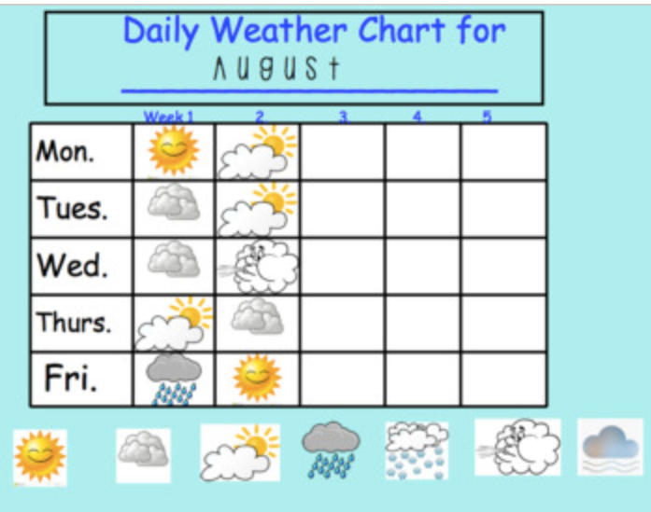 | Geography  What places do I belong?  What places do you belong to? What other places are you familiar with?  What are the use of those places and how do people have a sense of belonging?  Record with drawings and words: What places our class belongs to.  Ex. JPS, Mosque,  big stump, sporting places.  A common place people like to visit is the park.  What might you hear, smell, feel and see at the park?  Act out and film what you might do at the park.  Do you think you can belong to more than one country?  Watch video and discuss  https://www.youtube.com/watch?v=YBrx7zDQlU0&t=60s | Creative Arts  Lucky dip emotions.  Students will take turns acting out an event that triggers certain emotions.  Angry  happy  Excitement  Sad  Annoyed  Bored  Devastated  Proud  Embarrassed  Brave  Shy  Scared | Mrs Sandberg-  PD/H/PE  Learning goal:  Understand how respect is an important part of interacting positively with others.  What do you think respect means?  Please watch the video R.E.S.P.E.C.T. with the WonderGrove Kids:  https://www.youtube.com/watch?v=k-6ws8LZECU  Respect is a way of treating or thinking about someone who you like or care about.  1: Draw a picture of you being respectful.  2: Draw a picture of 3 things you need to respect in the classroom or at home.  Look at the different dance moves pictures.  Choose the moves you like the best (at least 5) and make up a dance, using all of your moves.  If you like, you can take a photo or video of your dance and share on SeeSaw. Play your favourite music and practice your dance moves! | Number Talk  Choral counting  by 10s  Reflection/Sharing:  This week I found the learning:  My favourite activity was:  The hardest activity was:  Something that I am looking forward to on the weekend is:
Wellbeing | Complete the mindfulness activity:  https://youtu.be/ZBnPlqQFPKs | Complete the mindfulness activity:  https://youtu.be/jKSkAtFUjo0 | Complete the mindfulness activity:  https://www.youtube.com/watch?v=56_8aK3cLEA | Complete the mindfulness activity:  https://youtu.be/ljQxIzUQihs | Complete the mindfulness activity:  https://www.youtube.com/watch?v=fTzXFPh6CPI

